

**CPCCWHS1001**

**WORK SAFELY IN THE CONSTRUCTION INDUSTRY**

Table Of Contents

PCCWHS1001A

WORK SAFELY IN THE

CONSTRUCTION INDUSTRY

LEARNER GUIDE

Module One – OHS/WHS Legislative Requirements

1.1 Introduction 4

1.1.1 Course Overview **5**

1.1.2 What Is Construction Work? **6**

1.2 OHS/WHS Requirements 7

1.2.1 Harmonisation Of Work Health & Safety Legislation 7

1.2.1.1 Key Elements Of The Work Health & Safety Legislation 7

1.2.2 National Code Of Practice For Induction For Construction Work 10

1.2.3 Who Does General Induction Training Apply To? 11

1.3 Duty Of Care 12

1.4 Safe Work Practices 13

1.4.1 Access To Site Amenities Such As Drinking Water And Toilets 13

1.4.2 Drugs And Alcohol At Work 14

1.4.3 Plant And Equipment Including Licencing, Competency And Refresher Training 14

1.4.4 Wearing Personal Protective Equipment And Clothing 15

1.4.5 Housekeeping 16

1.4.6 Storing Materials And Equipment Properly 16

1.4.7 Correctly Storing And Removing Debris 17

1.4.8 Preventing Bullying And Harassment 17

1.4.9 Smoking On Site 17

Appendix 1A – Work Health & Safety Common Terms And Definitions 18

2.1 Risk Management 19

2.1.1 Consultation And Communicating With Others 21

2.1.2 Risk/Hazard Identification 22

2.1.2.1 Construction Hazards 24

2.1.3 Risk Assessment 25

2.1.3.1 Risk Analysis 25

2.1.3.2 Risk Evaluation 26

2.1.4 Risk Treatment 28

2.1.4.1 Consider Hazard/Risk Control Strategy Options 29

2.1.4.2 Identify The Resources Required To Implement The Control Strategy 30

2.1.4.3 Is The Control Strategy Practical And Realistic? 30

2.1.4.4 Implement The Control Strategy 31

2.1.4.5 Review Of The Risk Treatment Plan 32

2.1.5 Monitor and Review Risk Management Process 33

2.1.6 Reporting And Record Keeping 34

3.1 OHS/WHS Communication 36

3.1.1 OHS/WHS Information And Documentation 37

3.1.2 OHS/WHS Reports And Forms 38

3.1.3 OHS/WHS Personnel 39

3.1.4 Common Workplace Signage 40

3.2 Workplace Emergencies 41

3.2.1 Emergency Response 41

3.2.1.1 Sample Evacuation Procedure 42

3.3 First Aid Response 43

3.4 Workplace Incidents 44

3.5 Reporting All Hazards, Incidents And Injuries 45

3.5.1 Workers Compensation 46

3.6 Personal Protective Equipment 47

3.7 Fire Safety Equipment 48

Appendix 3C – OHS/WHS State Regulators 51

1.1 Introduction

This training kit is based on the National Unit of Competency **CPCCWHS1001A: Work Safely in the Construction Industry.**

This unit specifies the outcomes required to undertake Occupational Health & Safety /Work Health & Safety (OHS/WHS) induction training within the construction industry.

It requires the ability to demonstrate personal awareness of OHS/WHS legislative requirements, and the basic principles of risk management and prevention of injury and illness in the construction industry. Licencing requirements will apply to this unit depending on the regulatory requirements of each jurisdiction.

This unit of competency supports the attainment of the basic OHS/WHS knowledge required prior to undertaking designated work tasks within any of the sectors within the construction industry. The unit relates directly to the general induction training program specified by the National Code of Practice for Induction Training for Construction Work (ASCC 2006).

1.1.1 Course Overview

This course offers the general OHS/WHS induction information you require to work on a construction site in Australia.

The course covers:

* The Occupational Health & Safety/Work Health & Safety legislative framework.
* Hazards and risks.
* Construction industry knowledge.
* Accidents and incidents.
* Site safety.

After completing this course participants will have a basic knowledge of OHS/WHS legislative requirements, particularly as they pertain to your roles and responsibilities as a professional involved in the construction industry.

Participants will also have a good understanding of the main hazards in the construction industry and the common principles of risk control.

1.1.2 What Is Construction Work?

The National Code of Practice for Induction for Construction Work defines construction work as:

***“Any work on or in the vicinity of a construction site carried out in connection with the construction, alteration, conversion, fitting out, commissioning, renovation, repair, maintenance, de-commissioning, demolition or dismantling of any structure, and includes:***

* ***The demolition or dismantling of a structure, or part of a structure, and the removal from the construction site of any product or waste resulting from the demolition or dismantling***
* ***The assembly of prefabricated elements to form a structure or the disassembly of prefabricated elements, which, immediately before such disassembly, formed a structure***
* ***Any work in connection with any excavation, landscaping, preparatory work, or site preparation carried out for the purpose of any work referred to in this definition, and***
* ***Any work referred to in this definition carried out under water, including work on buoys, obstructions to navigation, rafts, ships, and wrecks.***

***It does not include the exploration for or extraction of mineral resources or preparatory work relating to the extraction carried out at a place where such exploration or extraction is carried out.”***

1.2 OHS/WHS Requirements

OHS/WHS legislation is defined as laws and guidelines to help keep your workplace safe.

These can be broken down into four main types:

|  |  |
| --- | --- |
| **Acts** | Laws to protect the health, safety and welfare of people at work. |
| **Regulations** | Gives more details or information on particular parts of the Act. |
| **Codes of Practice / Compliance Codes** | Are practical instructions on how to meet the terms of the Law. |
| **Australian Standards** | Give you the minimum levels of performance or quality for a hazard, work process or product. |

1.2.1 Harmonisation Of Work Health & Safety Legislation

In response to industry calls for greater national consistency, the Commonwealth, states and territories have agreed to implement nationally harmonised Work Health & Safety (WHS) legislation to commence on 1 January 2012.

While not all states and territories have actually implemented the model WHS legislation as of the start of 2012, it is important to be aware of these changes, as all states and territories will eventually implement them.

Harmonisation aims to develop consistent, reasonable and effective safety standards and protections for all Australian workers through uniform WHS laws, regulations and codes of practice.

1.2.1.1 Key Elements Of The Work Health & Safety Legislation

The following key elements of the WHS legislation will impact the way you do your job, and the responsibilities of your workplace:

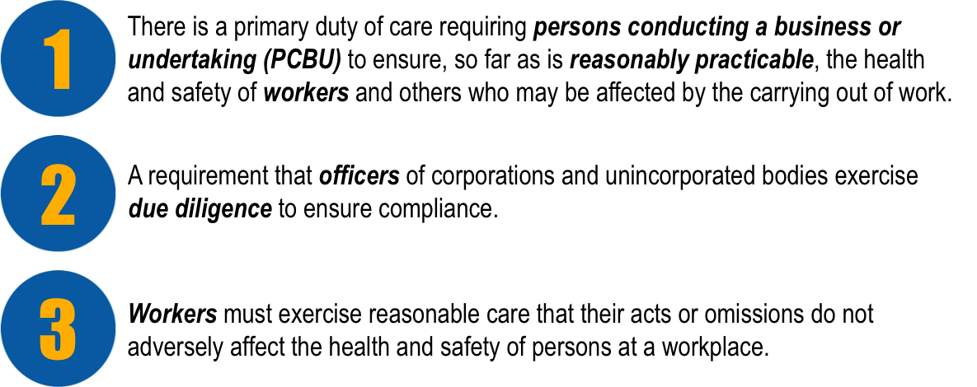

The legislation also outlines requirements for:

* The reporting requirements for notifiable incidents.
* Licences, permits and registrations (e.g. for persons engaged in high risk work or users of certain plant or substances).
* Provision for worker consultation, participation and representation at the workplace.
* Provision for the resolution of health and safety issues.
* Protection against discrimination.

Many specific details relating to WHS will be negotiated within the workplace in accordance with the legislation.

It is important that you speak with your Health & Safety Representative or supervisor for more information on how these elements will effect your day-to-day operations, or if you have any concerns relating to health and safety.

A list of common WHS terms and their definitions can be found in appendix 1A.

It is important that you are familiar with the OHS/WHS laws that exist in your state or territory. Each state in Australia has its own OHS/WHS legislation and regulations that must be followed.

The following OHS/WHS legislative requirements will affect the way that you work in the construction industry:

* Australian Standards.
* Construction Industry OHS/WHS Standards and Guidelines.
* Duty of Care.
* Health & Safety Representatives, Committees and Supervisors.
* Licences, Tickets or Certificates of Competency
* National safety standards.
* OHS/WHS and Welfare Acts and regulations.
* Safety Codes of Practice.

Talk to your OHS/WHS officer or representative if you have any questions about legislative requirements.

1.2.2 National Code Of Practice For Induction For Construction Work

The National Code of Practice for Induction for Construction (2007) work provides guidance to general and residential construction workers on the types of induction training to provide an awareness and understanding of common construction workplace hazards and how they should be managed.

The code of practice outlines the requirements of induction training across 3 different areas:

* **General** – Safety training used to provide basic knowledge of OHS legislative requirements and risk management processes in the construction industry.
* **Site** – This training occurs when you arrive at a site and provides information about specific OHS issues or requirements for that particular site (or part of that site).
* **Task-specific** – This induction provides information relating to OHS issues for a specific work activity undertaken by a particular occupation, industry sector or occupation.

The purpose of these training materials is to meet the requirements of **General Induction Training**.

1.2.3 Who Does General Induction Training Apply To?

The code of practice recommends general induction training for the following people, occupations and tasks:

* Casual, part-time or labour-hire persons performing construction work.
* Owners carrying out construction work.
* Installation of joinery, pre-cast concrete panels, windows.
* Delivery drivers dropping off materials inside the construction zone.
* Engineers and surveyors who undertake preparatory site work.
* Cleaning and maintenance of structures under construction.
* Work experience students undertaking construction work.
* Traffic control for on-site construction work.
* Finishing and fit-out work such as painting, tiling, carpet laying, floor sanding.
* Landscaping.

1.3 Duty Of Care

Both you and your employer/PCBU have a legal responsibility under duty of care to do everything reasonably practicable to protect others from harm in the workplace.

Duty of care applies to:

* Employers/PCBU and self-employed persons.
* Persons in control of the worksite.
* Supervisors.
* Manufacturers and suppliers.
* Workers.
* Subcontractors and inspectors.

**Your own** responsibilities are to comply with safe work practices, including activities that require licences, tickets or certificates of competency, as well to help the employer/PCBU on WHS matters. You should take reasonable care to protect the health and safety of yourself and others through your actions at work.

**Your employer’s/PCBU’s** responsibility is to provide a safe working environment, systems, equipment, personal protective equipment (PPE), facilities, WHS information, first aid, instruction and training. This safe environment should also extend to protecting members of the public or visitors to the construction site.

1.4 Safe Work Practices

Safe work practices are the actions that you take while at work to minimise the chance of causing harm to yourself, others or equipment.

It is your responsibility to make sure that you work in a safe way to avoid accidents.

1.4.1 Access To Site Amenities Such As Drinking Water And Toilets

There should be toilets and clean drinking water on site for you to use. It is your responsibility to make sure the toilet facilities are clean and hygienic.

Drink plenty of water during the day to keep yourself hydrated, especially if you are working outside in the sun. Dehydration can cause fatigue and make it harder for you to concentrate.

1.4.2 Drugs And Alcohol At Work

Drugs and alcohol can affect your ability to concentrate and work safely. You are a danger to yourself and to those around you when working under the influence of drugs and alcohol.

1.4.3 Plant And Equipment Including Licencing, Competency And Refresher Training

For some jobs in the construction industry, special training or a licence is required to ensure they are carried out safely. These may include:

* Driving a forklift.
* Erecting scaffolding over 4 metres.
* Dogging, rigging and directing cranes.
* Hoist and crane operation.
* Using earthmoving equipment.
* Handling dangerous materials.
* Working in confined spaces.
* Plumbing, electrical and building work.

1.4.4 Wearing Personal Protective Equipment And Clothing

Personal protective equipment (PPE) can help to reduce the effects or chance of being hurt.

PPE includes:

* Hard hats.
* Earmuffs.
* Safety goggles.
* Boots.
* Gloves.
* High-visibility (hi-vis) clothing.
* Respiratory equipment.
* Aprons.
* Arm guards.
* UV-protective clothing and sunscreen.

***Make sure that you have at least the minimum PPE required at all times.***

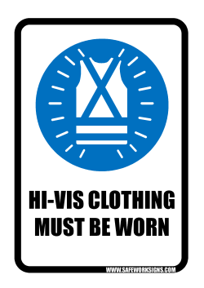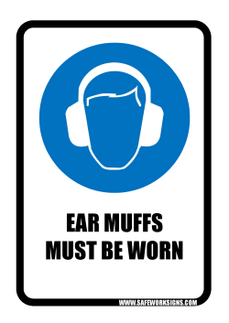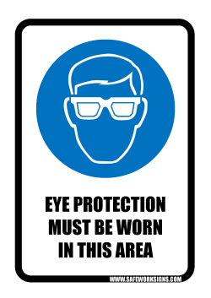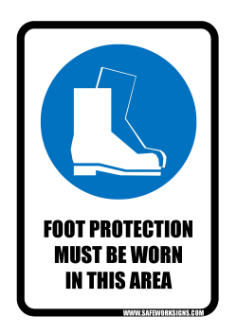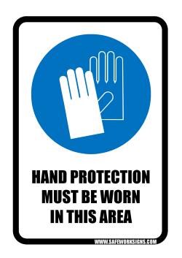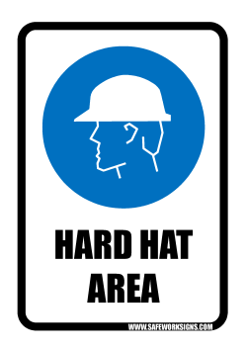

1.4.5 Housekeeping

Clean up any rubbish you make as you work to help prevent tripping accidents, or accidents caused by flying debris.

1.4.6 Storing Materials And Equipment Properly

Make sure all equipment and materials are stored properly and safely.

Stack materials neatly so that they don’t fall out on the next person who tries to get to them.

Make sure all equipment is stored according to the manufacturer’s instructions.

1.4.7 Correctly Storing And Removing Debris

Dispose of any debris properly without impacting negatively on the environment. Make sure all materials are collected and removed properly.

1.4.8 Preventing Bullying And Harassment

Bullying is not tolerated in any workplace. If you are being bullied or see somebody else being bullied you must report it.

1.4.9 Smoking On Site

Only smoke in designated areas away from flammable materials.

Smoking around flammable materials is extremely dangerous. Make sure you don’t do it!

Appendix 1A – Work Health & Safety Common Terms And Definitions

|  |  |
| --- | --- |
| **Person Conducting a Business or Undertaking (PCBU)** | A ‘person conducting a business or undertaking’ (PCBU) replaces the term ‘employer’. A PCBU includes all employers, sole traders, principal contractors, unincorporated associations, partnerships and franchisees. Volunteer organisations that also employ people will be PCBUs.  A PCBU’s primary duty of care is to ensure the health and safety of everyone in the workplace, so far as is reasonably practicable. |
| **Officers** | An ‘Officer’ is a person who makes, or participates in making, decisions that affect the whole or a substantial part of a corporation. This includes Health and Safety Representatives (HSR). |
| **Workers** | ‘Worker’ replaces the term ‘employee’. It is defined broadly to mean a person who carries out work in any capacity for a PCBU.  A ‘worker’ covers employees, contractors, sub-contractors (and their employees), labour hire employees, outworkers, apprentices, trainees, work experience students and volunteers. |
| **Reasonably Practicable** | Reasonably Practicable is defined as action that is, or was at a particular time, reasonably able to be done to help ensure health and safety based on the following factors:   1. Chances of the hazard or risk occurring (likelihood). 2. The degree of harm (consequence). 3. The knowledge of persons involved in the situation relating to the hazard or risk and methods of eliminating or controlling it. 4. The availability and suitability of ways to eliminate or control the hazard or risk. 5. The costs involved in taking action to eliminate or control the hazard or risk including consideration of whether the cost involved is inconsistent to the level of risk. |
| **Due Diligence** | The Occupational Health and Safety Act 2004 (the OHS Act 2004) imposes a specific duty on officers of corporations to exercise due diligence to ensure that the corporation meets its work health and safety obligations. In short, they have a responsibility to ensure that the PCBU is doing everything it should to ensure health and safety.  The duty requires officers to be proactive in ensuring that the corporation complies with its duty.  Due diligence may be demonstrated through the following courses of action:   1. Acquiring knowledge of health and safety issues. 2. Understanding operations and associated hazards and risks. 3. Ensuring that appropriate resources and processes are used to eliminate or minimise risks to health and safety. 4. Implementing processes for receiving and responding to information about incidents, hazards and risks. 5. Establishing and maintaining compliance processes. 6. Verifying the provision and use of the resources mentioned in 1-5. |
|  |  |

2.1 Risk Management

Risk management is the process of reducing or managing the risks when working with a hazard or in a hazardous situation and should take into consideration the context of the organisation and worksite.

Risk management must be conducted in accordance with:

* Legislative, organisation and site requirements/procedures.
* Australian Standards (AS/NZS ISO 31000:2009).
* Codes of Practice.
* Employment and workplace relations legislation.
* Equal employment opportunity and disability legislation.

**HAZARDS CREATE RISK. CHECK FOR HAZARDS.**

A **RISK** is the chance of a hazard hurting you or somebody else or causing some damage.

A **HAZARD** is the thing or situation that causes injury, harm or damage.

If you can remove or at least control a **HAZARD** you can reduce the **RISK** involved.

Risk management is the process of identifying risks or hazards so that you can take action to eliminate or control them.

Risk management is made up of the following stages:

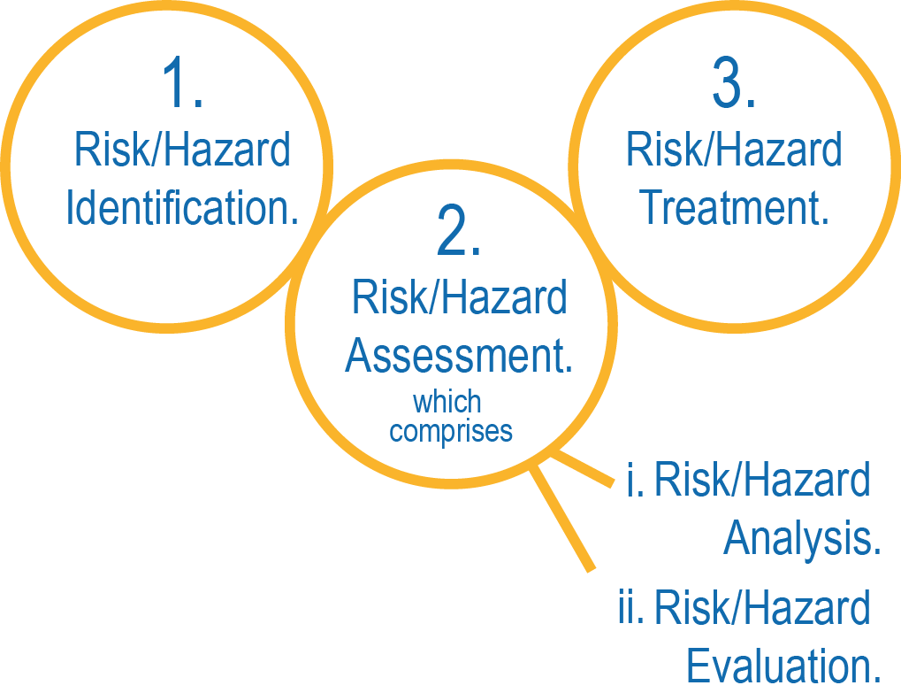

Consultation, reporting, communicating with others, monitoring and review should be planned for and carried out at every stage of the risk management process.

2.1.1 Consultation And Communicating With Others

Communication and consulting with others is an important part of the risk management process and should take place at all stages.

Identifying risks and hazards and coming up with ways of controlling them includes talking to the people with knowledge of the situation, or who are directly affected by any action you may take.

You should always talk to any workers involved in the hazard control measures as well as the OHS/WHS officer or supervisor. This will help ensure that risks and hazards are not only effectively identified but that those involved with controlling and treating them are clear of their role and responsibilities in the risk management process.

It also allows different skills, expertise and views to be brought together to enhance and support the risk management process.

It is important that different views and concerns are identified and recorded as part of the consultation and then taken into account during the decision-making process.

Controlling a hazard can be a team effort and it’s important that everybody knows what they need to do and how/if they need to change their work process to suit.

2.1.2 Risk/Hazard Identification

Each worksite has its own specific risks and hazards. A site induction needs to inform you of any hazards which exist on site. Some of these hazards can be removed through staff training, better equipment and safe work methods. Talk to the OHS/WHS officer for more information.

Each specific worksite will have risk management procedures, safety systems and information, and procedures for communication, reporting and record keeping.

Before conducting a risk assessment at a worksite, check to see what systems and procedures are in place as they may affect the outcomes of the risk assessment. It is important that suitably knowledgeable personnel/workers are involved in the risk identification process.

To identify possible risks and hazards walk all around the work area and check:

**Up High**

Hazards could include: obstructions, power lines, trees, scaffolding, cranes.

**Eye Level**

Hazards could include: other workers, equipment, machines, hazardous materials, obstructions.

**Down Low**

Hazards could include: surface condition, spills, debris, underground services, weight-bearing ability.

Make a note of any hazard you identify in the area. Remember, a hazard can also be a situation so keep an eye on how the people around you are working too.

You should also check records of injuries and incidents, safety tags and talk to other workers.

Material Safety Data Sheets (MSDS) can be useful tools in identifying potential hazards so make sure you check the MSDS documents for your site.

Hazards are not only environmental, and may be caused by the way a job is carried out, or by the equipment being used.

Each task/procedure/function needs to be evaluated for risks, as well as the work area where the work is being carried out.

You need to recognise the type and scope of risks that are yet to be resolved and understand the likely impact so as to evaluate the situation and begin to implement control measures.

2.1.2.1 Construction Hazards

Construction hazards could include the following:

|  |  |
| --- | --- |
| **Hazard** | **Description** |
| Confined spaces. | Could suffocate. |
| Chemical spills. | Could cause fire and explosion, toxic atmosphere, burns, or uncontrolled reaction with other chemicals, or environmental contamination. |
| Electrical safety. | Could be electrocuted. |
| Excavations, including trenches. | Could fall in, could collapse. |
| Falling objects. | Could cause damage to property or injury to personnel/workers. |
| Fire | Could cause damage to property or injury to personnel/workers. |
| Hazardous substances and dangerous goods. | Exposure may cause injury. |
| HIV and other infectious diseases. | Could contract diseases from unsafe or unhygienic facilities. |
| Liquids under pressure | Could cause an explosion and injury |
| Hot and cold working environments (temperatures). | Could cause dehydration/sunburn or exposure to cold could cause hypothermia. |
| Manual handling. | Could cause injury (strain). |
| Noise, dust and vapours | Could cause hearing, breathing or vision problems. |
| Plant and equipment. | Could be struck by or injured while using mobile equipment. |
| Traffic and mobile plant. | Could be hit by moving vehicles. |
| Unplanned collapse. | Could cause damage to property or injury to personnel/workers. |
| Ultraviolet (UV) radiation. | Could cause sunburn. |
| Working at heights. | Could fall from height, objects could fall from heights. |
| Overhanging beams and protrusions | Objects could fall from heights and/or cause injury to personnel. |
| Sharp equipment | Could cause injury to personnel |

Once a risk has been identified check for any existing procedural documentation, workplace procedure or workplace policy, which describes how to eliminate or control the risk. It is important that all records, policies and procedures are kept up to date so that the most relevant information is available and used.

Talk to other workers, your manager, supervisor, team leader or health & safety representative to find out if the risk has already been addressed, and what techniques are available to you to resolve it.

If you find that there is no documentation or guideline in place to resolve an identified risk, you need to assess the risk and identify a feasible course of action to deal with it.

2.1.3 Risk Assessment

A risk assessment involves completing a risk analysis and a risk evaluation.

2.1.3.1 Risk Analysis

Risk analysis involves considering what are the causes and sources of risks and comprises 3 factors:

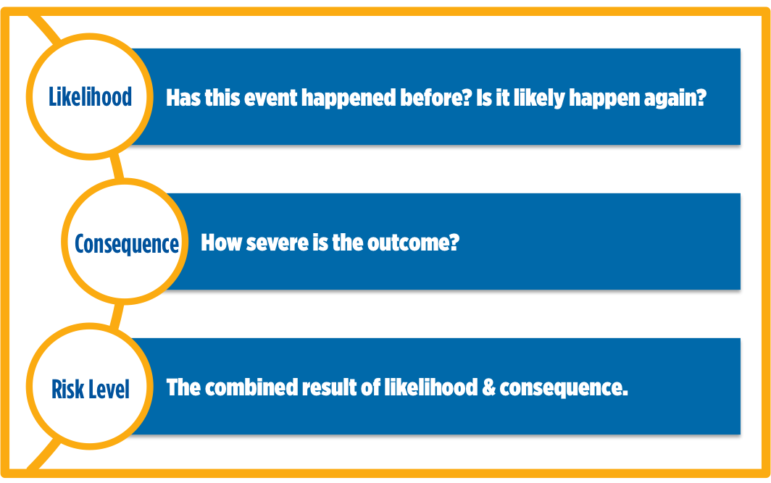

Using a table similar to the one shown here you can analyse how high the risk level is.

|  |  |  |  |  |  |
| --- | --- | --- | --- | --- | --- |
| **LIKELIHOOD** | **CONSEQUENCE** | | | | |
| **Insignificant** | **Minor**  First Aid Required | **Moderate**  Medical Attention and Time Off Work | **Major**  Long Term Illness or Serious Injury | **Severe**  Kill or Cause Permanent Disability or Illness |
| **Almost Certain** | **M** | **H** | **H** | **VH** | **VH** |
| **Likely** | **M** | **M** | **H** | **H** | **VH** |
| **Possible** | **L** | **M** | **H** | **H** | **VH** |
| **Unlikely** | **L** | **L** | **M** | **M** | **H** |
| **Rare** | **L** | **L** | **M** | **M** | **M** |

2.1.3.2 Risk Evaluation

Risk evaluation is based upon the outcomes and results of the risk analysis.

Risk evaluation involves making decisions about which risks need to be treated and the order in which they should be treated.

It should take into consideration the context of the risks in relation to:

* The organisation.
* The worksite.
* The relevant laws.
* Regulations.
* Other policies, procedures and requirements.

Using a table similar to the one shown you can evaluate how soon you should act to remove or control the hazard to achieve an acceptable level of risk.

|  |  |
| --- | --- |
| **RISK LEVEL** | **ACTION** |
| **VERY HIGH** | Act immediately:  The proposed task or process activity must not proceed. Steps must be taken to lower the risk level to as low as reasonably practicable using the hierarchy of risk controls. |
| **HIGH** | Act today:  The proposed activity can only proceed, provided that:   1. The risk level has been reduced to as low as reasonably practicable using the hierarchy of risk controls. 2. The risk controls must include those identified in legislation, Australian Standards, Codes of Practice etc. 3. The risk assessment has been reviewed and approved by the Supervisor. 4. A Safe Working Procedure or Safe Work Method has been prepared. 5. The supervisor must review and document the effectiveness of the implemented risk controls. |
| **MEDIUM** | Act this week:  The proposed task or process can proceed, provided that:   1. The risk level has been reduced to as low as reasonably practicable using the hierarchy of risk controls. 2. The risk assessment has been reviewed and approved by the Supervisor. 3. A Safe Working Procedure or Safe Work Method has been prepared. |
| **LOW** | Act this month:  Managed by local documented routine procedures, which must include application of the hierarchy of controls. |

Any task with a Very High risk level is absolutely unacceptable to carry out. Steps must be taken to reduce the risk level.

2.1.4 Risk Treatment

Once risks have been identified, analysed and evaluated, risk treatment options need to be considered and applied.

Risk treatment involves selecting one or more options to modify a risk and then implementing the selected option/s. Risk treatments should be recorded in a risk treatment plan.

Once an option has been implemented it may be referred to as a risk control.

2.1.4.1 Consider Hazard/Risk Control Strategy Options

The Hierarchy of Hazard Control is the name given to a range of control methods used to eliminate or control hazards and risks in the workplace. The Hierarchy has 6 levels:

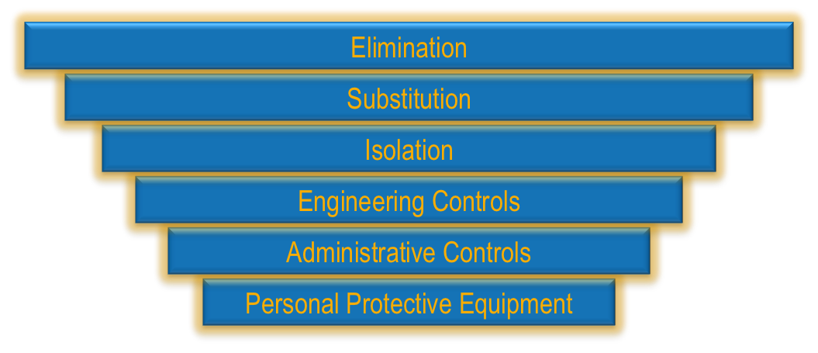

|  |  |
| --- | --- |
| **1. Elimination** | Completely remove the hazard. This is the best kind of hazard control. |
| **2. Substitution** | Swap a dangerous work method or situation for one that is less dangerous. |
| **3. Isolation** | Isolate or restrict access to the hazard. |
| **4. Engineering Measures** | Use equipment to lower the risk level. |
| **5. Administrative/ Safe Work Practices** | Site rules and policies attempt to control a hazard. |
| **6. Personal Protective Equipment** | The least effective control. Use PPE while you carry out your work. |

It is important to consider all of the options available when deciding on the best course of action. Not all options are feasible or possible under some circumstances.

You may need to use a number of control measures in conjunction to reduce the risk level to an acceptable level. The risk treatment plan should clearly identify the order in which to implement the individual risk treatments.

2.1.4.2 Identify The Resources Required To Implement The Control Strategy

These resources should also be outlined in the risk treatment plan and could include:

* New or different equipment.
* Staff training.
* More personnel/workers.
* Creation of procedures and instructions.
* Fencing or traffic control.

2.1.4.3 Is The Control Strategy Practical And Realistic?

Once you have determined the course of action that achieves the greatest reduction in risk, and the resources required to implement it, you need to determine if this is feasible (practical and realistic).

* How long will the implementation take?
* What will it cost?
* How many people will it involve?
* Are special requirements, permits or training required?

All of these factors need to be considered when deciding on the course of action to take.

2.1.4.4 Implement The Control Strategy

Once you have come to the conclusion that the action is appropriate, feasible and reduces the level of risk to an acceptable level it is time to take action and implement the control measures.

Plan out, in detail, the steps required to implement the control strategies. This plan is called the Risk Treatment Plan. Consult with other workers and management to ensure the implementation is done correctly and does not have a negative bearing on other trades, procedures or workers.

With the risk control measure in place you will need to review the level of risk to determine if more needs to be done to lower the risk level.

The acceptable level of risk is determined by an organisation’s policy, goals and objectives towards safety. Talk to your supervisor or health & safety representative if you are not sure about whether or not the risk has been reduced enough to carry out the work.

If you determine the risk to be at an unacceptable level, the work must not be carried out until the situation can be reviewed by an authorised person.

2.1.4.5 Review Of The Risk Treatment Plan

The risk treatment plan documents how the chosen risk treatment options will be implemented. The risk treatment plan should also include:

* The reasons and expected benefits of the chosen risk treatments.
* Those responsible for approving and implementing the plan.
* The actions proposed to be taken.
* All resources required.
* How work should be carried out with the controls in place.
* Requirements for reporting and monitoring of the treatment.
* The timing and schedule for the implementation of the treatment.

Risk treatment plans should be discussed with appropriate personnel/workers and included within the management processes of the organisation.

2.1.5 Monitor and Review Risk Management Process

Monitoring and review are an important part of the risk management process and should be planned for at every stage.

Monitoring and review involves regular surveillance and checking and responsibilities concerning it should be clearly defined.

Monitoring and review should:

* Ensure that treatments and controls are effective and efficient.
* Aim to improve risk assessment through obtaining further information.
* Be used to analyse events and changes that have occurred through the implementation of the process and any lessons that may be learned from this.
* Be used to detect any changes, including changes to risks, which may require revision of treatments, or the emergence of new risks.

It is important that monitoring and review results are recorded and reported according to organisational policies and procedures.

2.1.6 Reporting And Record Keeping

Make sure you record any action you’ve taken and talk to your supervisor and OHS/WHS officer about the control strategies in place.

Reports and records could include:

* Risk Assessment Reports.
* Incident Reports.
* Job Safety Analysis.
* Safe Work Method Statements.

Keeping records is important as they can help ensure that any risk management activities are traceable. Records also provide a basis for improving methods and tools in the risk management process, as well as improving the overall process.

|  |  |  |  |  |  |
| --- | --- | --- | --- | --- | --- |
| **LIKELIHOOD** | **CONSEQUENCE** | | | | |
| **Insignificant** | **Minor**  First Aid Required | **Moderate**  Medical Attention and Time Off Work | **Major**  Long Term Illness or Serious Injury | **Severe**  Kill or Cause Permanent Disability or Illness |
| **Almost Certain** | **M** | **H** | **H** | **VH** | **VH** |
| **Likely** | **M** | **M** | **H** | **H** | **VH** |
| **Possible** | **L** | **M** | **H** | **H** | **VH** |
| **Unlikely** | **L** | **L** | **M** | **M** | **H** |
| **Rare** | **L** | **L** | **M** | **M** | **M** |

|  |  |
| --- | --- |
| **RISK LEVEL** | **ACTION** |
| **VERY HIGH** | Act immediately:  The proposed task or process activity must not proceed. Steps must be taken to lower the risk level to as low as reasonably practicable using the hierarchy of risk controls. |
| **HIGH** | Act today:  The proposed activity can only proceed, provided that:   1. The risk level has been reduced to as low as reasonably practicable using the hierarchy of risk control. 2. The risk controls must include those identified in legislation, Australian Standards, Codes of Practice etc. 3. The risk assessment has been reviewed and approved by the Supervisor. 4. A Safe Working Procedure or Safe Work Method has been prepared. 5. The supervisor must review and document the effectiveness of the implemented risk controls. |
| **MEDIUM** | Act this week:  The proposed task or process can proceed, provided that:   1. The risk level has been reduced to as low as reasonably practicable using the hierarchy of risk controls. 2. The risk assessment has been reviewed and approved by the Supervisor. 3. A Safe Working Procedure or Safe Work Method has been prepared. |
| **LOW** | Act this month:  Managed by local documented routine procedures, which must include application of the hierarchy of controls. |

3.1 OHS/WHS Communication

It is a legal requirement that you are able to access and contribute to OHS/WHS information in the workplace. It encourages employers and workers to cooperate to ensure health and safety for everyone.



OHS/WHS information can be gained through:

* 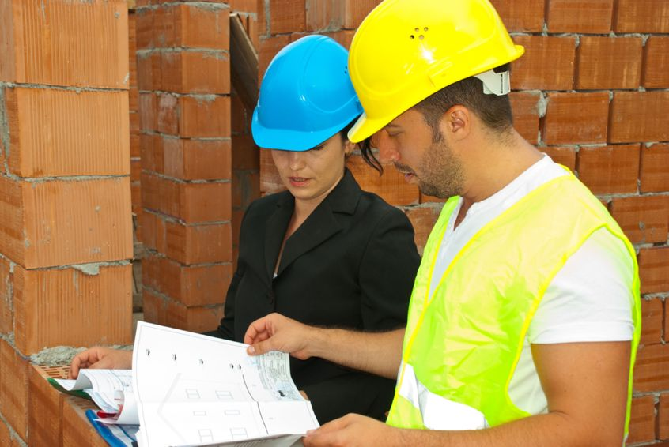Discussions with OHS/WHS representatives.
* OHS/WHS meetings.
* OHS/WHS notices, newsletters, bulletins and correspondence.
* OHS/WHS participative arrangements.
* Processes for raising OHS/WHS issues.
* Toolbox talks.
* Workplace consultation relating to OHS/WHS issues and changes.

3.1.1 OHS/WHS Information And Documentation

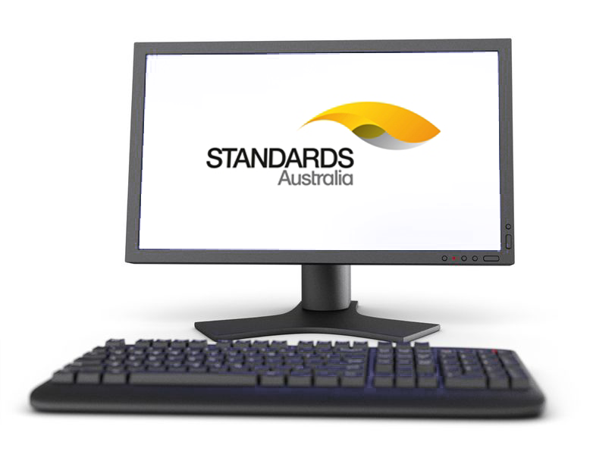OHS/WHS information and documentation must be made available to you. Documentation could include:

* Accident and incident reports.
* Acts and regulations.
* Australian standards.
* Codes of practice/Compliance Codes.
* Construction documentation and plans.
* Online (Industry and Government websites such as Safe Work Australia)

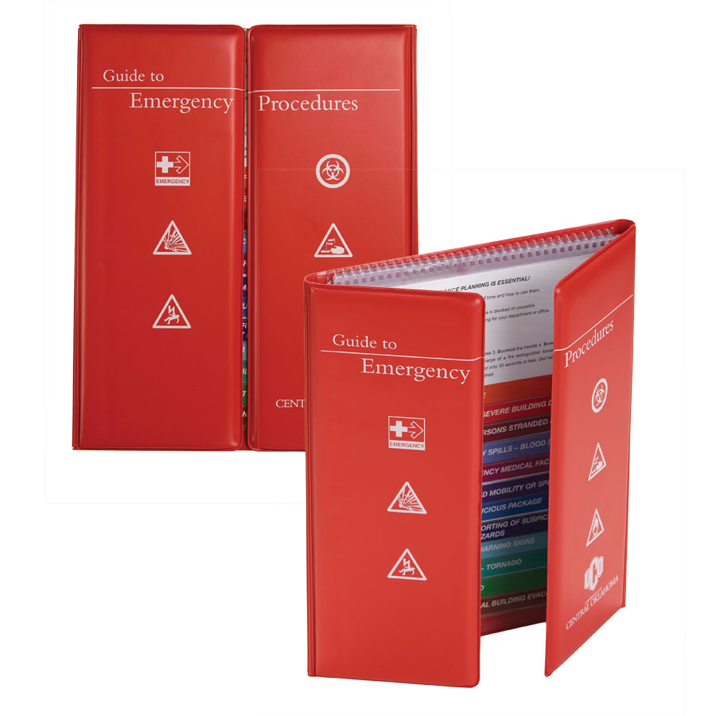

* Emergency information contact.
* Evacuation plans.
* First aid plan
* Guidance notes.
* Job Safety Analyses.
* Safe Work Method Statements.
* Information from Supervisor/PCBU or other workers
* 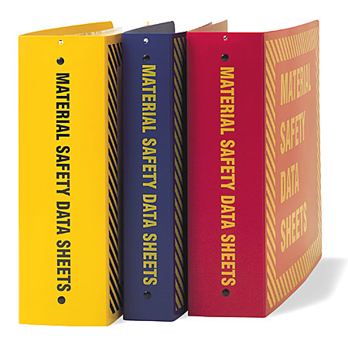Labels.
* Material Safety Data Sheets (MSDS).
* Proformas for reporting hazards, incidents and injuries.
* Reports of near misses and dangerous occurrences.
* Risk assessments.
* Safety meeting minutes.
* Site safety inspection reports.

3.1.2 OHS/WHS Reports And Forms



Site Safety Inspection Reports

Before starting work it is important to check that the worksite is safe. Once you have completed a check, record any hazards that you have found and report to your supervisor or OHS/WHS representative to decide the best course of action.

Risk Assessment Reports

Once you have completed a risk assessment of any hazards you have found, it is important to record your observations and the actions you plan to take. This information will assist in the completion of the Safe Work Method Statement.

Safe Work Method Statement (SWMS)

A Safe Work Method Statement is a site-specific statement that must be prepared before any high-risk construction work is commenced. It covers the job and safety responsibilities of each member of a work group. Workers should be involved in discussions of tasks, associated hazards, risks and controls. See Appendix 3A for a copy of a Safe Work Method Statement.

Incident And Accident Reports

Incident and accident reports must be completed in the event of any incident. Use as much detail as possible when filling out these forms as it may have a bearing on the outcome of workers compensation and safety improvements in the workplace.

3.1.3 OHS/WHS Personnel

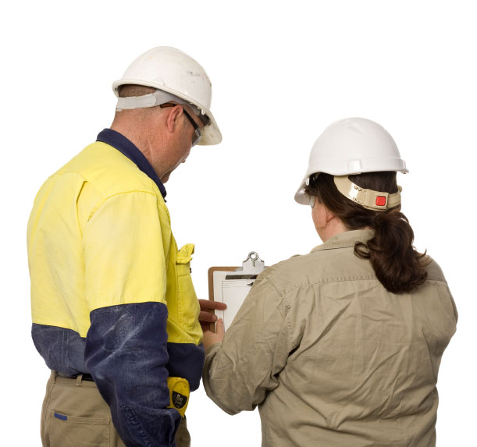There are a number of different people that you can talk to about various OHS/WHS issues:

* Your supervisor or manager (where there are no designated OHS/WHS people).
* Your OHS/WHS representative.
* Your workplace OHS/WHS committee.
* Emergency services staff.
* First aid officers.

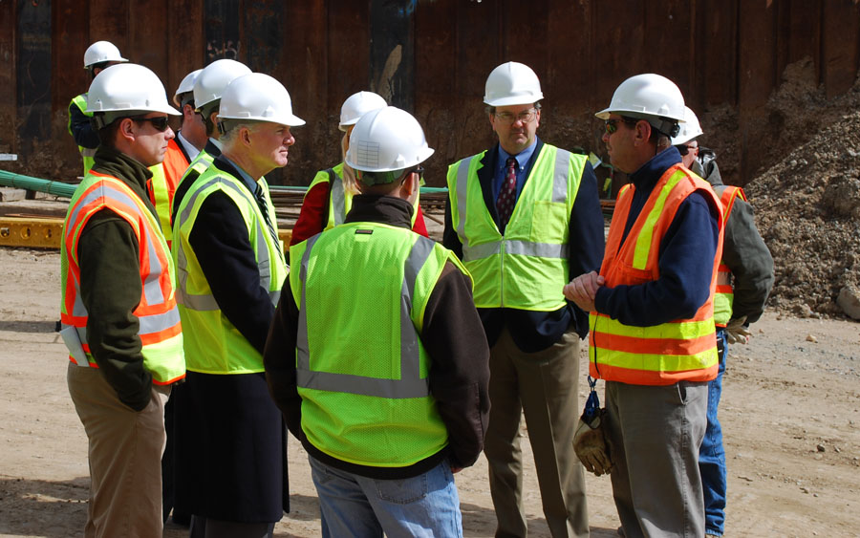It is important that you know who your OHS/WHS representative is. They are employed to represent your worksite and you as a worker.

Your OHS/WHS representative is there to give information on OHS/WHS, raise your views, interests and concerns to an OHS/WHS committee.



An OHS/WHS committee is a group of people on a worksite or in your company who decide on workplace safety issues.

They are responsible for looking at safety issues and suggesting ways of improving the work practices, use of equipment, communication and training of staff. They should meet every 6 months.

3.1.4 Common Workplace Signage

Another important safeguard method is the use of appropriate signage within and around the worksite. Signs have different colours, which represent instructions. For example: Red (do not), Blue (must do), Yellow (be aware) and Green (information).

|  |  |  |  |
| --- | --- | --- | --- |
| **Danger 11000 Volts.png** | **Warning Flammable Material.png** | **Prohibition_Authorised_Personnel_Only.png** | **Mandatory_Hard_Hat_Area.png** |
| **Danger Signs**  AS 1319 specifies that these signs are to be used where conditions are likely to be life threatening. The sign is to incorporate the word DANGER in white letters on a red oval shape inside a black rectangle. | **Warning Signs**  AS 1319 specifies that these signs warn of conditions that are NOT likely to be life threatening if the message is ignored. The symbol used is a yellow equilateral triangle with a black enclosure. | **Prohibition Signs**  AS 1319 specifies these signs are to have a red annulus and slash symbol on a white background. They indicate actions or activities that are not permitted. | **Mandatory Signs**  AS 1319 specifies these signs shall be a blue disc with the symbol in white. The word MUST is usually contained in the message. |
| Emergency_Assembly_Point.png |  |  |  |
| **Emergency Signs**  AS 1319 specifies these signs shall comprise of a white symbol or text on a green rectangle with white enclosure. These signs indicate the location or direction to emergency related facilities and first aid or safety equipment. | **Fire Signs**  AS 1319 - 1994 refers to fire signs which are covered in AS 2444 - 1995. These signs indicate the location of fire alarms and fire fighting equipment. Signs shall comprise a red rectangle sign with a white legend and enclosure. | **Hazchem Signs**  AS 1216 - 1995 specifies the relevant "designs, layout and size". These signs are prescribed in the "Australian Dangerous Goods Code" and various State Government "Dangerous Goods, Storage and Handling Regulations". | **Safety Tags & Lockout Systems**  These are isolation systems that help to prevent incidents by making sure faulty equipment is not used. A lockout prevents operation of equipment by an unauthorised person. Only the person who placed a tag or lockout device can remove it. |
| http://www.itsoftmedia.com/wp-content/uploads/2009/04/exit-signs.jpg | **Prohibition_5** | **Notice_Apply_Office** | **Mandatory_Site_Office** |
| **Site Safety, Directional, Traffic And Warning Signs And Symbols.** | | | |

3.2 Workplace Emergencies

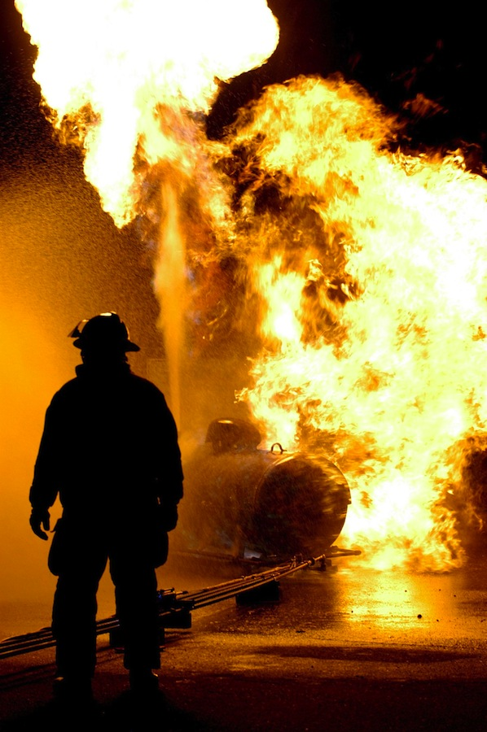Construction site emergencies may include:

* Fire.
* Gas leak.
* Toxic and/or flammable vapours emission.
* Vehicle/machine accident.
* Chemical spill.
* Injury to personnel/workers.
* Structural collapse.

DIAL ‘000’ IF THERE IS AN EMERGENCY

3.2.1 Emergency Response

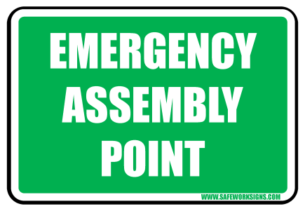In the case of an emergency:

* Remain calm.
* Raise the alarm with OHS/WHS personnel, your supervisor and/or first aid officer.
* Get help from emergency services (Dial 000).
* Evacuate if necessary (refer to site emergency plans).

3.2.1.1 Sample Evacuation Procedure

The purpose of an evacuation procedure or emergency plan is to prevent panic, poor judgement under pressure and breakdown of normal authority and communication. The following is an example of an evacuation procedure:

* 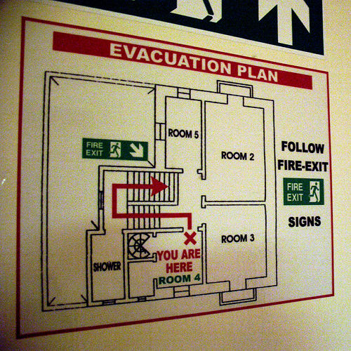Prepare to evacuate when the alarm is raised or when directed by a warden.
* Leave your worksite in a safe condition.
* Close the doors if there is a fire – DO NOT lock them.
* Help anyone in immediate danger.
* Leave the work area via the nearest safe route.
* Follow all directions from wardens and emergency services personnel.
* Move calmly to the nearest assembly point.
* Wait for the all-clear before returning to the work area.



3.3 First Aid Response

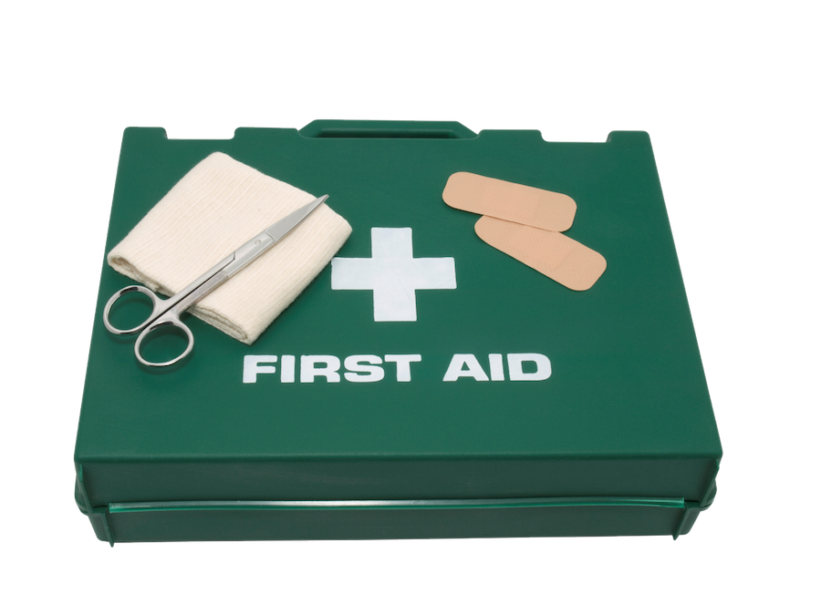

During and after a workplace emergency, first aid may need to be administered to individuals who have been affected.

First aid should only be provided by a trained and authorised person. Each work site will have first aid officers who will need to be informed of any injury that requires first aid care. Workers must know how to contact a first aider and access a first aid kit.

It is important that you know how to respond to any first aid situation. If you do not have first aid training you can still assist by carrying out the following procedures:

1. **Checking the immediate area for any danger** – before approaching any injured person check the area to make sure you are not putting yourself in any danger.
2. **Checking the condition of the person** – are they conscious or unconscious? Are they burned, bleeding or suffering some other kind of immediately identifiable injury?
3. **Sending for help** – this should be done as soon as possible. Get in contact with the site first aid officer or if need be, call 000 and request an ambulance.

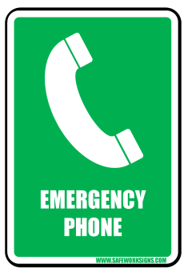

When speaking on the phone, try your best to maintain your composure, speak clearly to the telephone operator and try to answer all the questions as best you can.

There are situations where it maybe necessary to request the use of a bystander’s mobile phone to make the emergency call.

When calling emergency services (Dial 000) let the operator know the following details:

1. Where the emergency is.
2. What has happened.
3. Are there any injuries.
4. What is being done to solve the emergency.
5. Your name.
6. Who has been contacted

Do not hang up the phone until you have been given instructions on how to proceed.

3.4 Workplace Incidents

Description: Safety First Report All Accidents.pdfAn incident is defined as:

An accident resulting in personal/serious injury, death, or damage to property or, a near miss or dangerous occurrence which does not cause injury but may pose an immediate and significant risk to persons or property, and needs to be reported so that action can be taken to prevent recurrence.

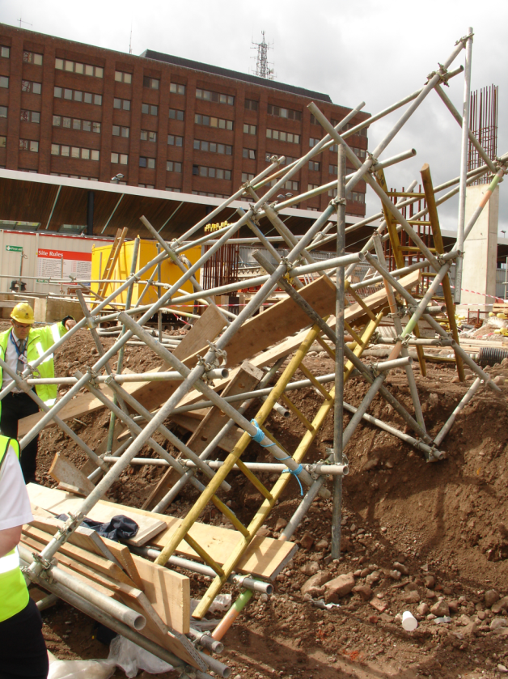Examples of incidents could include:

* Breathing apparatus malfunctioning to the extent that the user's health is in danger.
* Collapse of the floor, wall or ceiling of a building being used as a workplace.
* Collapse or failure of an excavation more than 1.5 metres deep (including any shoring).
* Collapse or partial collapse of a building or structure.
* Collapse, overturning or failure of the load bearing of any scaffolding, lift, crane, hoist or mine-winding equipment.
* 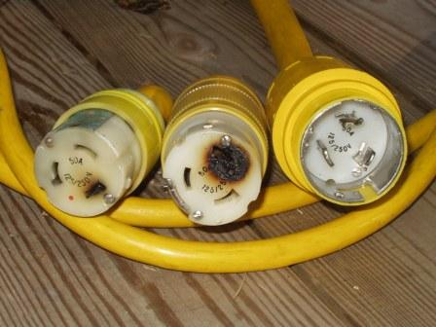Damage to or malfunction of any other major plant.
* Electric shock.
* Electrical short circuit, malfunction or explosion.
* Uncontrolled explosion, fire or escape of gas, hazardous substance or steam.
* Any other unintended or uncontrolled incident or event arising from operations carried on at a workplace.

All incidents MUST be reported!

3.5 Reporting All Hazards, Incidents And Injuries

Depending on the nature and severity of the situation you may need to report to:

* Your supervisor.
* Emergency services (e.g. police, ambulance, fire brigade and emergency rescue).
* OHS/WHS regulatory authority (e.g. WorkSafe, WorkCover).

All reports should be made in writing, verbally (face to face/phone) or using a relevant form. Ask your OHS/WHS representative, supervisor at the site office for the relevant forms and procedures for reporting hazards, incidents and injuries.

Incident report forms are available for recording the details of incidents in the workplace.

See Appendix 3B for a copy of an Injury and Dangerous Occurrence Report Form.

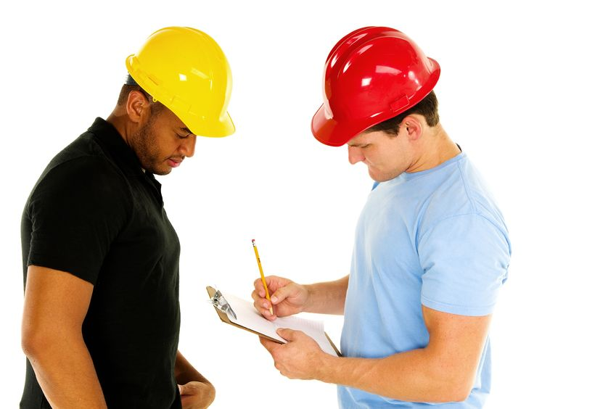

3.5.1 Workers Compensation

If you are injured at work you are eligible for workers compensation. This applies to all personnel/workers.

Workers compensation can help cover lost wages and the costs of medical expenses.

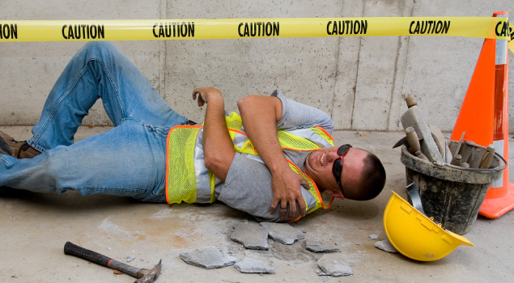

If injured, you must complete a claim form promptly after an injury, and keep a copy for your own records. You must also get a medical clearance before returning to work.

Contact the OHS/WHS regulatory authority in your state for more information.

See Appendix 3C for contact details of the regulators in each state and territory.

3.6 Personal Protective Equipment

Each workplace and job requires different personal protective equipment (PPE). These items are often a mandatory requirement of entering work areas.

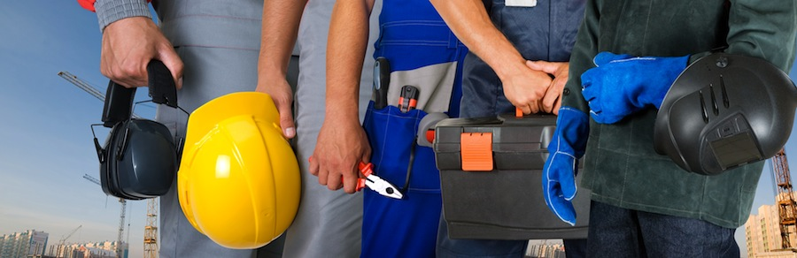

Depending on workplace requirements, environmental factors, and requirements of the job to be done, you may have to wear any of the following:

* Aprons.

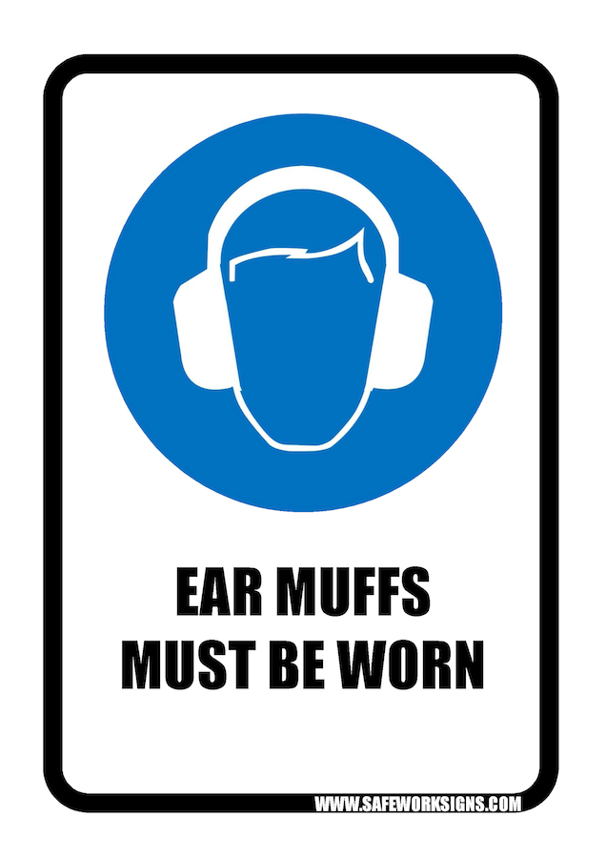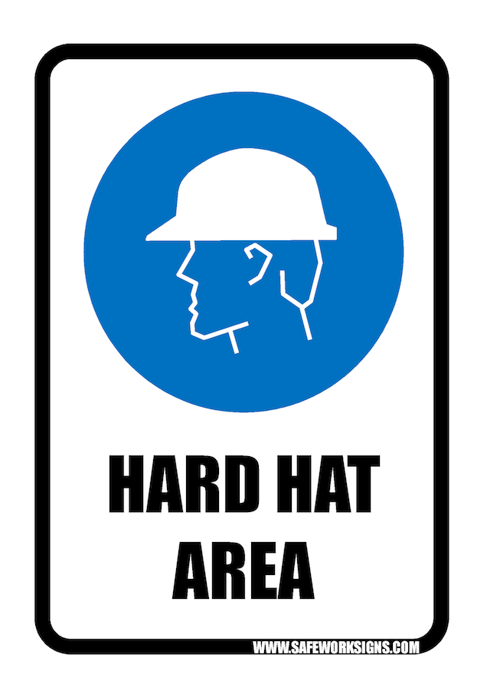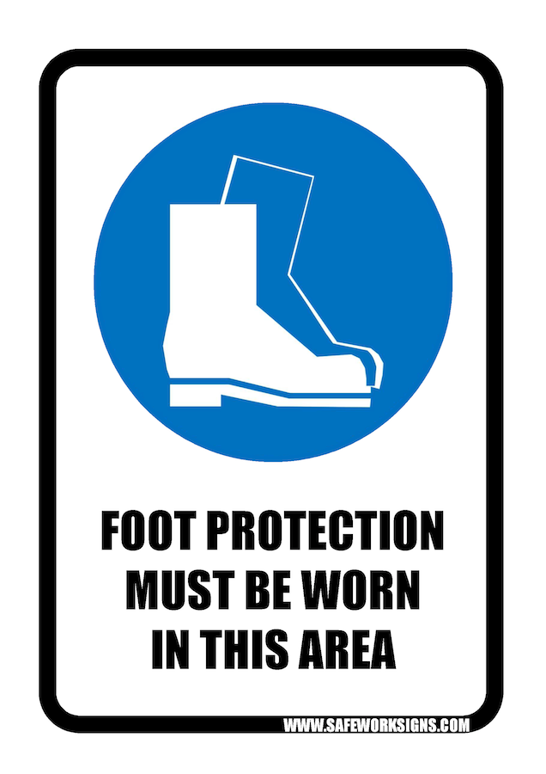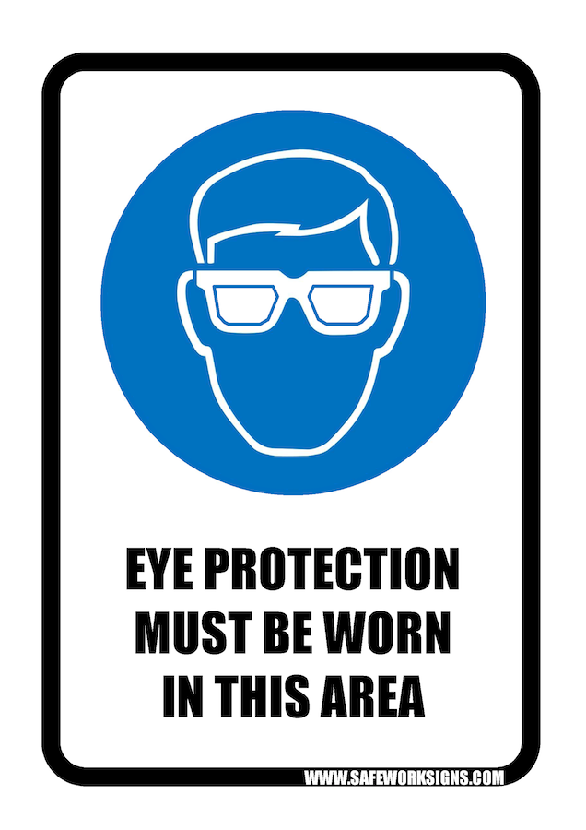

* Arm guards.
* Eye protection. (e.g. goggles)
* Hand protection (e.g. gloves).
* Headwear (e.g. hard hat).
* Hearing protection (e.g. muffs)
* High-visibility retro-reflective vests.
* Protective, well-fitting clothing.
* Respiratory protection. (e.g. ½ or full mask respirator)
* Safety footwear. (e.g. boots)
* UV-protective clothing and sunscreen.

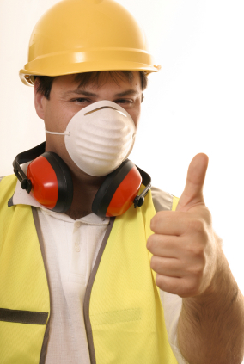

If you are not familiar with an item of PPE, ask a competent person to show you how to use it.

3.7 Fire Safety Equipment

There a 6 common causes of fires in the workplace. They are; chemical, electrical, started by explosion, started by friction, caused by flammable materials, or caused by mechanical/welding. The fire safety equipment that is commonly available on construction worksites may include the following:

|  |  |
| --- | --- |
| **Breathing Apparatus**  A self-contained breathing apparatus (SCBA) is a device worn by rescue workers, fire-fighters, and others to provide breathable air in situations with an immediate danger to life and health. |  |
| **Fire Blanket**  Fire blankets are ideal for settings where small Class F fires are a risk such as in kitchens or wherever oils or fats are exposed to potential ignition.  They can also be used if a person’s clothing has caught fire. |  |
| **Fire Extinguisher**  Portable fire extinguishers can save lives and property by putting out or containing fires within the capability of the extinguisher.  However, they must be of the correct type for the particular fire, and they must be used correctly. |  |
| **Fire Hose Reel**  Fire hose reels provide a reasonably accessible and controlled supply of water to combat a potential Class A fire risk.  All fire hose reels must comply with Australian Standard AS/NZS1221. |  |

|  |  |  |  |  |  |  |  |  |  |  |  |
| --- | --- | --- | --- | --- | --- | --- | --- | --- | --- | --- | --- |
| Key:  Green = Suitable  Orange = Limited Effect  Red = Do Not Use | | | Type of Extinguisher/Extinguishing Agent | | | | | | | | |
| Water | Foam | Carbon Dioxide (CO2) | Powder AB(E) | Powder BE | Wet Chemical | Vaporising Liquid | Fire Blanket | Fire Hose Reel |
|  | | |  |  |  |  |  |  |  |  |  |
|  | Class A | Wood, Paper. Plastic Etc. |  |  |  |  |  |  |  |  |  |
| Class B | Flammable & Combustible Liquids |  |  |  |  |  |  |  |  |  |
| Type of Fire | Class C | Flammable Gases |  |  |  |  |  |  |  |  |  |
| Class D | Combustible Metal Fires | Specific, special purpose powder extinguishers are available for Class D metal fires.  **Seek Expert Advice**. | | | | | | | | |
|  | Class E | Electrically Energised Equipment |  |  |  |  |  |  |  |  |  |
| Class F | Cooking Oils And Fats |  |  |  |  |  |  |  |  |  |

**Risk Analysis Matrix**

Use this table to determine the level of risk associated with an identified hazard.

|  |  |  |  |  |  |
| --- | --- | --- | --- | --- | --- |
| **LIKELIHOOD** | **CONSEQUENCE** | | | | |
| **Insignificant** | **Minor**  First Aid Required | **Moderate**  Medical Attention and Time Off Work | **Major**  Long Term Illness or Serious Injury | **Severe**  Kill or Cause Permanent Disability or Illness |
| **Almost Certain** | **M** | **H** | **H** | **VH** | **VH** |
| **Likely** | **M** | **M** | **H** | **H** | **VH** |
| **Possible** | **L** | **M** | **H** | **H** | **VH** |
| **Unlikely** | **L** | **L** | **M** | **M** | **H** |
| **Rare** | **L** | **L** | **M** | **M** | **M** |

|  |  |
| --- | --- |
| **RISK LEVEL** | **ACTION** |
| **VERY HIGH** | Act immediately:  The proposed task or process activity must not proceed. Steps must be taken to lower the risk level to as low as reasonably practicable using the hierarchy of risk controls. |
| **HIGH** | Act today:  The proposed activity can only proceed, provided that:   1. The risk level has been reduced to as low as reasonably practicable using the hierarchy of risk controls. 2. The risk controls must include those identified in legislation, Australian Standards, Codes of Practice etc. 3. The risk assessment has been reviewed and approved by the Supervisor. 4. A Safe Working Procedure or Safe Work Method has been prepared. 5. The supervisor must review and document the effectiveness of the implemented risk controls. |
| **MEDIUM** | Act this week:  The proposed task or process can proceed, provided that:   1. The risk level has been reduced to as low as reasonably practicable using the hierarchy of risk controls. 2. The risk assessment has been reviewed and approved by the Supervisor. 3. A Safe Working Procedure or Safe Work Method has been prepared. |
| **LOW** | Act this month:  Managed by local documented routine procedures, which must include application of the hierarchy of controls. |

Appendix 3C – OHS/WHS State Regulators

The table below lists the contact details for each regulatory authority in each state:

|  |  |  |
| --- | --- | --- |
| **Australian Capital Territory** | **Worksafe ACT (ACT WorkCover)**  Phone: (02) 6207 3000  Email: worksafe@act.gov.au  Website: [www.worksafe.act.gov.au](http://www.worksafe.act.gov.au) | |
| **New South Whales** | **WorkCover Authority of NSW**  Phone: 13 10 50  Website: [www.workcover.nsw.gov.au](http://www.workcover.nsw.gov.au) | |
| **Northern Territory** | **NT WorkSafe**  Phone: 1800 019 115  Email: ntworksafe@nt.gov.au  Website: [www.worksafe.nt.gov.au](http://www.worksafe.nt.gov.au) | |
| **Queensland** | **Workplace Health and Safety Queensland**  1300 369 915  [www.deir.qld.gov.au/workplace/index.htm](http://www.deir.qld.gov.au/workplace/index.htm) | **WorkCover (Queensland)**  Phone: 1300 362 128  Email: info@workcoverqld.com.au  Website: [www.workcoverqld.com.au](http://www.workcoverqld.com.au) |
| **South Australia** | **SafeWork SA**  Phone: 1300 365 255  Email: help@safework.sa.gov.au  Website: [www.safework.sa.gov.au](http://www.safework.sa.gov.au) | **WorkCover SA**  Phone: 13 18 55  Website: [www.workcover.com](http://www.workcover.com) |
| **Tasmania** | **WorkSafe Tasmania**  Phone: 1300 366 322 (Tasmania) /  National (03) 6233 7657  Email: [wstinfo@justice.tas.gov.au](mailto:wstinfo@justice.tas.gov.au)  Website: [www.worksafe.tas.gov.au](http://www.worksafe.tas.gov.au) | **WorkCover Tasmania**  Phone: 1300 776 572  Email: workcover@justice.tas.gov.au  Website: www.workcover.tas.gov.au |
| **Victoria** | **WorkSafe Victoria**  Phone: 1800 136 089  Email: info@worksafe.vic.gov.au  Website: [www.worksafe.vic.gov.au](http://www.worksafe.vic.gov.au) | |
| **Western Australia** | **WorkSafe WA**  Phone: 1300 307 877  Email: safety@commerce.wa.gov.au  Website: www.safetyline.wa.gov.au | **WorkCover WA**  Phone: 1300 794 744  Website: www.workcover.wa.gov.au |